Readme File

MushCafe Website Documentation

1. Introduction
The MushCafe website is a simple and elegant restaurant website designed using HTML and CSS.
It was created to showcase the café’s brand, menu, services, and gallery in a responsive and visually appealing way.
The project consists of:
- index.html → the main website structure.
- style.css → the external stylesheet controlling design and layout.
- images/ → folder containing all the image assets.
- Menu/ → folder containing all the prices for food you want.
- About Us/ → folder containing the information needed about Cafe.
- Contact Us/ → folder containing the contact information
- Our Services/ → folder containing details about the services the café provides (e.g., catering, home delivery, special events).
- Enquiries/ → folder contains where customer can make a feedback about the meal they ordered or an experience about the Café’

2. How the Website Works
- Header Section: Includes the restaurant name, tagline, and logo styled with gradients, borders, and shadows.
- Navigation Bar: Sticky navigation that stays visible at the top, with hover effects for interactivity.
- Menu and Services: Structured lists that use flexbox for alignment and hover animations.
- Gallery: Built using CSS Grid, images adjust automatically to the screen size.
- Footer: Contains copyright and branding.
The website is fully responsive, meaning it adjusts for desktop, tablet, and mobile views.

3. How I Created style.css

3.1 Base Styles
- Set a global font-family ('Segoe UI', Arial, sans-serif) for consistency.
- Applied a soft cream background (#fff8e1) to give a warm and welcoming café theme.
- Reset margins and used line-height: 1.6 for readability.

3.2 Header Styling
- Used a linear-gradient (red shades) for a vibrant header background.
- Styled the logo image as a circle with border-radius: 50%, gold border, and a box shadow.
- Applied larger, bold headings (font-size: 2.5rem) and italic tagline text.

3.3 Navigation Bar
- Created a sticky navbar (position: sticky; top: 0;) so links stay visible when scrolling.
- Styled links in white, with hover effects that change the color to gold (#ffca28) and underline with a border.

3.4 Sections
- Each section uses a white card design with rounded corners (border-radius: 20px) and box shadows for depth.
- Section headings use red text (#b71c1c) with a golden underline effect (::after pseudo-element).

3.5 Menu & Services
- Menu and service items are styled as flexbox rows with justify-content: space-between.
- Each list item has a soft pink background (#fce4ec) and a bold left border (6px solid #b71c1c).
- Hover effects slightly shift the item (transform: translateX(6px)) and change the background.

3.6 Gallery
- Used CSS Grid: grid-template-columns: repeat(auto-fit, minmax(200px, 1fr)) for responsiveness.
- Images are styled with width: 100% and height: auto to scale properly.
- Hover effects slightly enlarge (scale(1.07)) and darken shadows.

3.7 Footer
- Dark background (#212121) with centered white text.
- Smaller font size to make it subtle but readable.

4. Responsive Design
- The site is responsive due to:
  - CSS Grid in the gallery.
  - Flexbox in lists.
  - Percentage-based images (max-width: 100%; height: auto;).
- On smaller screens, content stacks vertically while maintaining readability.
Homepage Logo
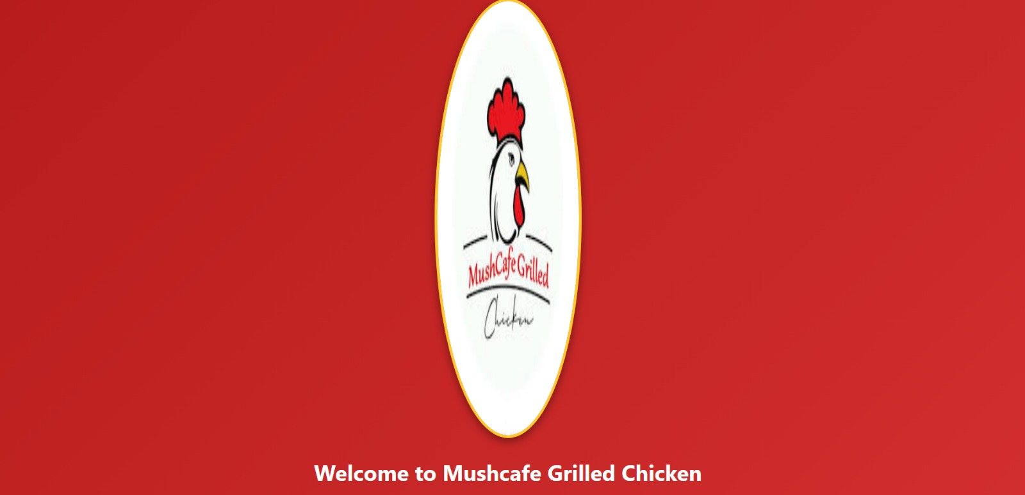
https://www.facebook.com/61550552383706

Gallery
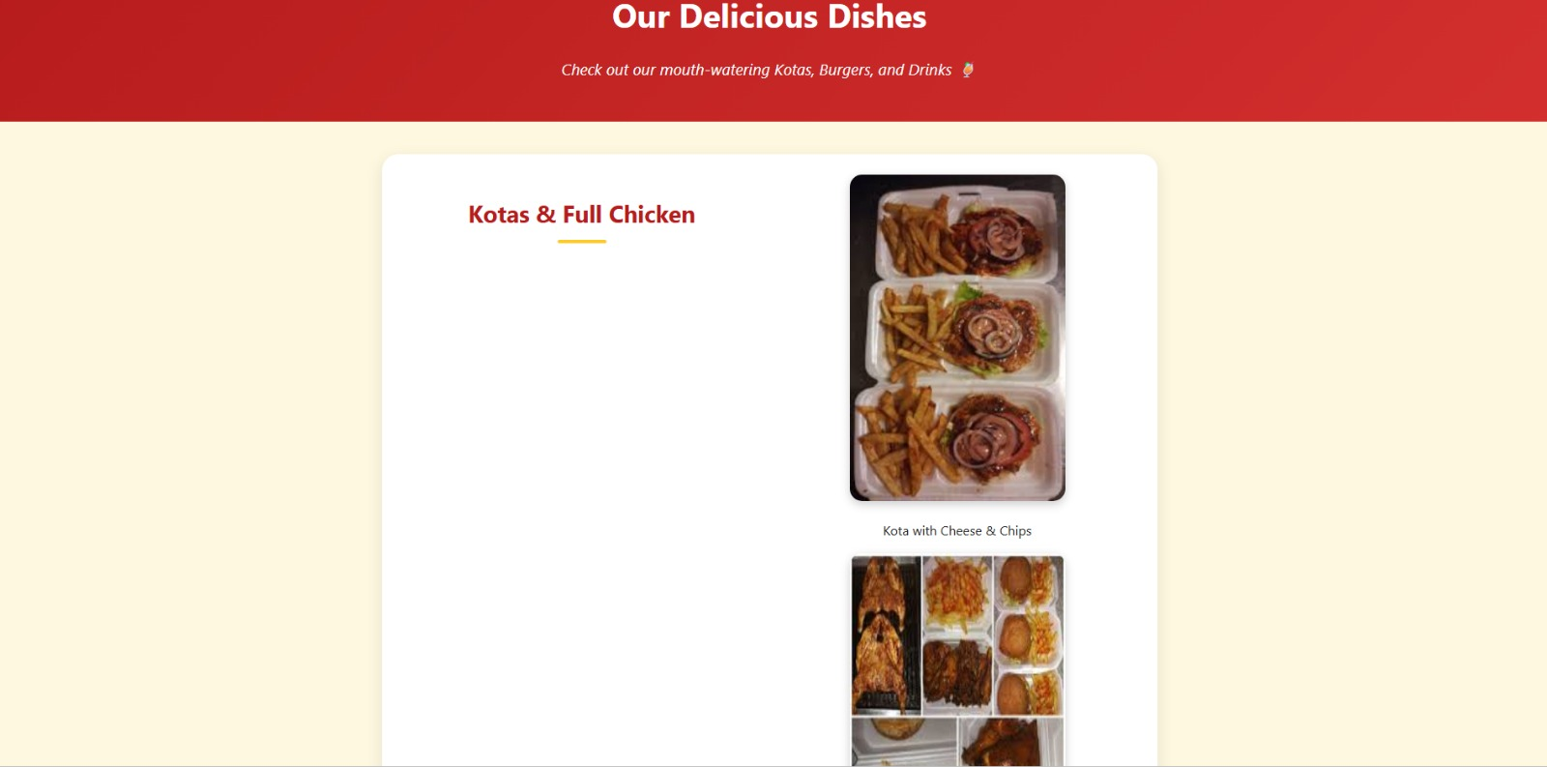

https://www.facebook.com/p/MushCafe-Grilled-Chicken-100077388126613/

Menu Prices
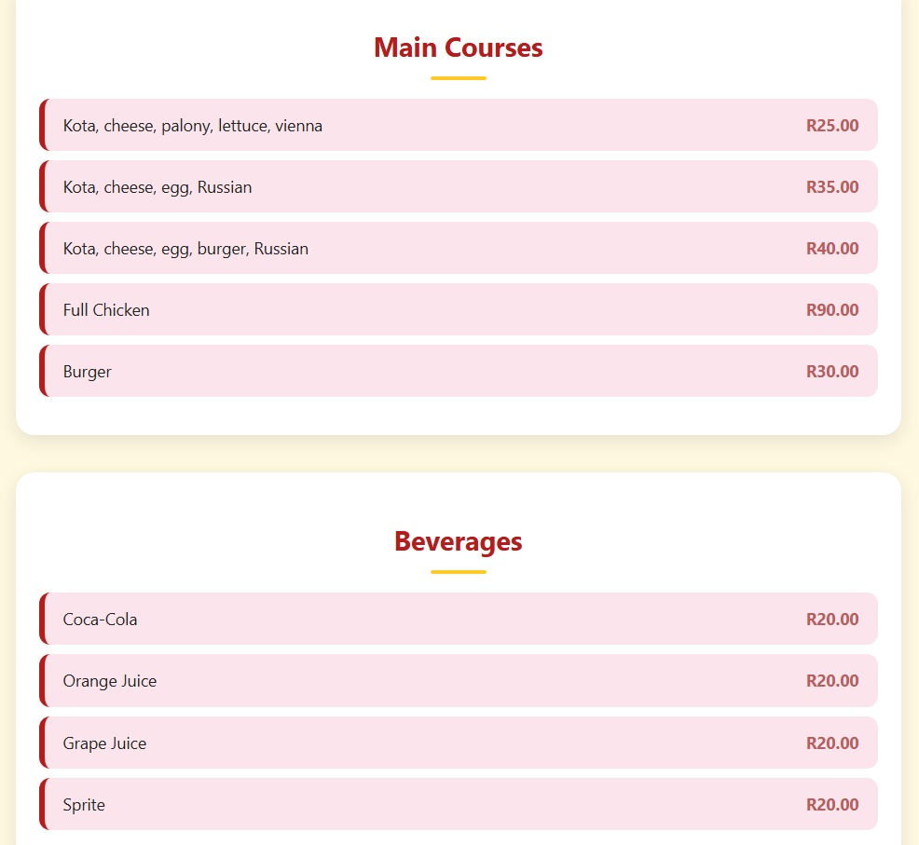
https://www.facebook.com/p/MushCafe-Grilled-Chicken-100077388126613/
About us
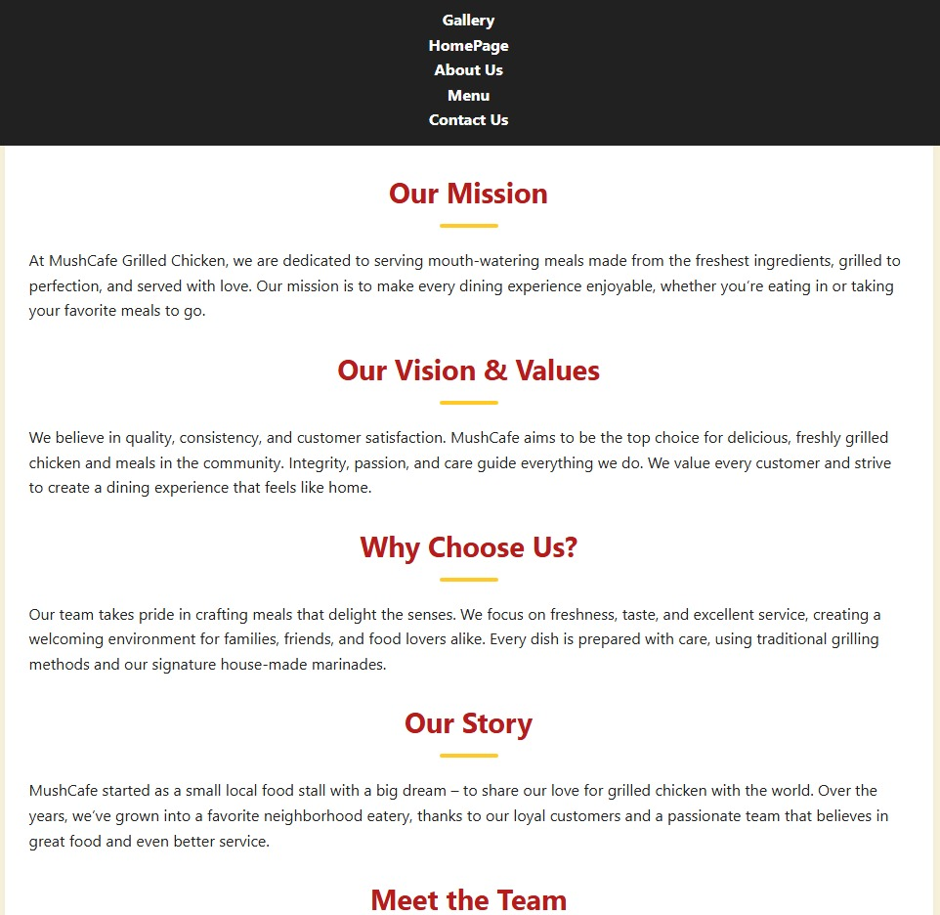

Contact us
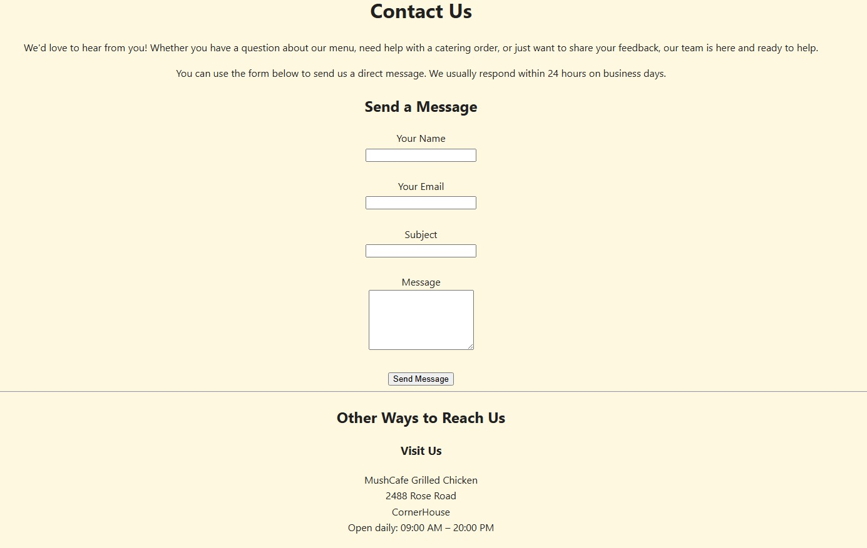

5. Conclusion
This project demonstrates how to use HTML for structure and CSS for styling to build a responsive, interactive website.
The use of gradients, shadows, transitions, flexbox, and grid helped create a modern and professional look for MushCafe.

Reference
- W3Schools (n.d.) How To – Create a Restaurant Website. W3Schools.[online] Available at: https://www.w3schools.com/howto/howto_website_restaurant.asp (Accessed: 25 September 2025).
- Wikipedia (n.d.) CSS Zen Garden. Wikipedia. [online] Available at: https://en.wikipedia.org/wiki/CSS_Zen_Garden (Accessed: 25 September 2025).
- Github link: https://github.com/ST10486114/Mushcafe-Website
please when opening my link click the Mushcafe website folder it has all the updated things in it.
- W3Schools (n.d,) How to add styling on my website. [online] available at: https://www.bing.com/ck/a?!&&p=3802a692c4a398b63b2631c521b215aca20e5f8f9d9c35fddad7cbb0248220e0JmltdHM9MTc1ODg0NDgwMA&ptn=3&ver=2&hsh=4&fclid=3c4f22f7-54ef-6d7d-10a0-376f55596c2c&psq=how+to+add+styling+on+my+website&u=a1aHR0cHM6Ly93d3cudzNzY2hvb2xzLmNvbS9DU1MvY3NzX2hvd3RvLmFzcA (Accessed: 26 September 2025).

